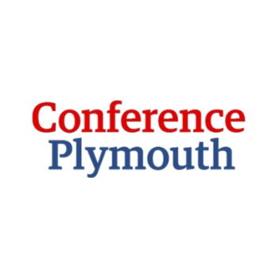 Press Release
Conference Plymouth launches a new website to target conference buyers to Britain’s Ocean City.

2018 has been an exciting year to date for Conference Plymouth with a launch of their new fresh branding and the rebuild of a multi-functional website to attract new corporate bookers to Plymouth Britain’s Ocean City.
The new website has a new search functionality which makes it easier for conference bookers to search for venues by capacity, themes or if they are looking for somewhere different in the city to host their conference. The website also showcases the benefits of hosting an event in Plymouth and highlights the key industries which are on offer in the city – marine science, manufacturing and tourism and hospitality.
Conference Plymouth is a membership organisation made up of great venues and unique suppliers from Plymouth and the surrounding areas and this website now enables each of the partner businesses to display more information about capacities, offers, news and social media feeds including video and pdf downloads.
Kim Downer, Vice Chair of Conference Plymouth/Plymouth Pavilions states “We are thrilled with the new website which gives us a great platform to showcase all the wonderful venues and suppliers we have on offer here in Plymouth for your conference, meeting or event.”
Sarah Gibson, Waterfront Manager and Chief Executive of Plymouth Waterfront Partnership said: “Conferences and corporate events, which Conference Plymouth are helping draw to the city, are of huge value to our businesses and the economy in Plymouth and the surrounding areas, so Plymouth Waterfront Partnership BID (Business Improvement District) is delighted to support Conference Plymouth and help fund the creation of this fantastic new website”.
Notes to Editors

Conference Plymouth is a membership organisation who works in partnership with the Plymouth Waterfront BID (Business Improvement District) to help promote Plymouth as a key destination for conferences, meetings and events.
Conference Plymouth offers a free venue finding service and helps conference bookers find the right venue and can assist in building social programmes to enhance an event.
Email: hello@conferenceplymouth.co.uk Website : www.visitplymouth.co.uk/conference

Press Contact - Jo Butler - jobutler22@outlook.com 07779349483

